Fast Tracking Your Branching Scenarios

  - Activity Worksheets

Learning Solutions Conference
April 19, 2022
Christy Tucker
christy@christytuckerlearning.com

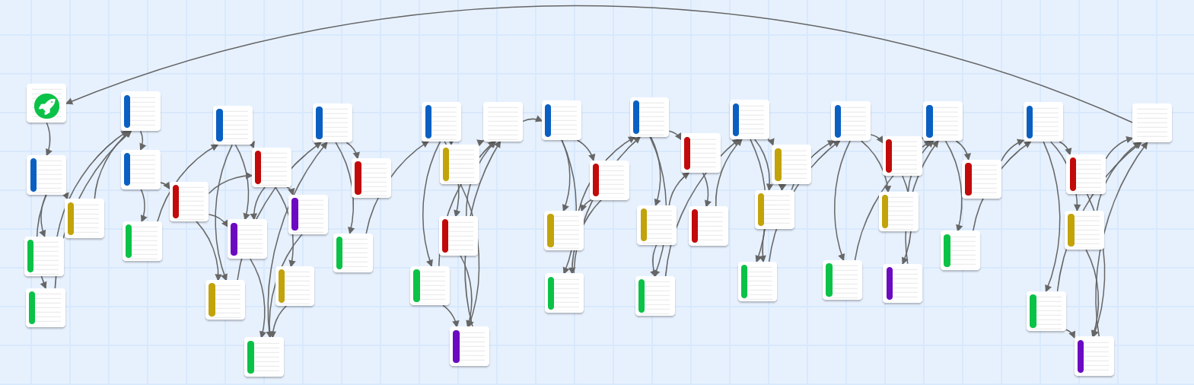

Activity 1: Objective and Desired Behavior 3
Activity 2: 4Cs 4
Main Character (Protagonist) 4
Other Characters 5
Context 5
Challenges 6
Consequences 6

Activity 1: Objective and Desired Behavior
What is the objective of your branching scenario? Focus on a single objective with one-specific action or behavior.

What does the desired behavior look or sound like?

At a high level, what are the steps if someone does the process or behavior perfectly? What is the “ideal path” in the branching scenario?

Activity 2: 4Cs

Plan your scenario in more detail with the characters, context, challenges, and consequences. Because you don’t have access to a SME, you may need to use your imagination for some details.

Main Character (Protagonist)
Who is your main character? Make sure their goals align with your objective.
Personal details | Goals and motivation
Job, role, work environment | Problems, challenges, worries, fears

Other Characters
Who are the other characters in the scenario? Use as many rows as you need (or skip this if your scenario only has a single character).
Name | Role | Details

Context
How could you set the context for your scenario? You may not use all of these ideas; just brainstorm for now.
Images
Language
Other ideas

Challenges
What are the challenges your character faces in your scenario? What mistakes could your main character make?
Challenges

Consequences
What are some of the consequences that could happen in the scenario?
Consequences

